LETSUPGRADE DATA STRUCTURES AND ALGORITHMS

DAY 6 ASSIGNMENT

Q1) Write a function to find the maximum element in the stack.

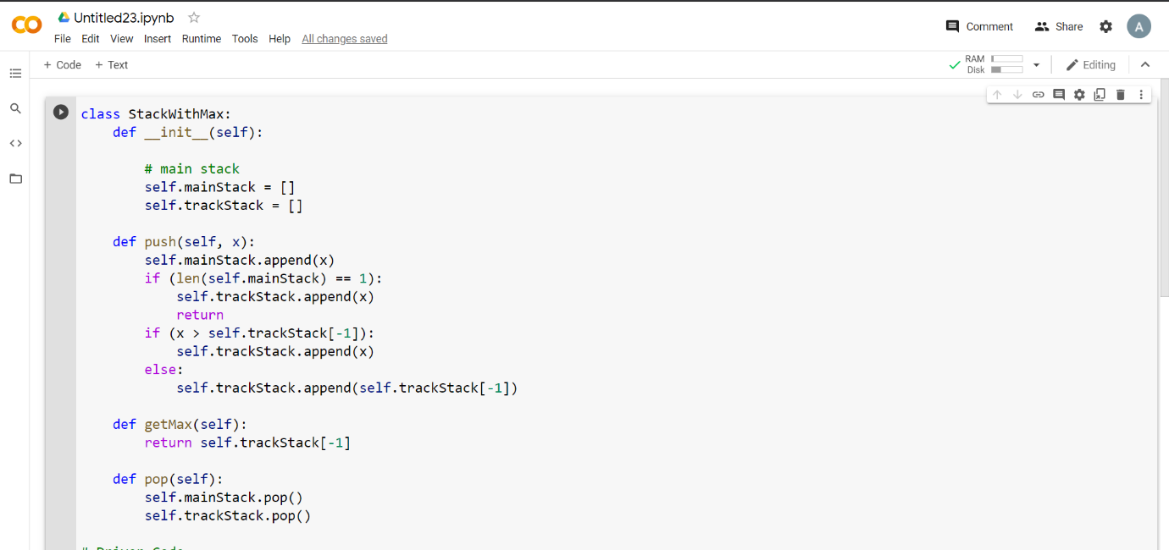

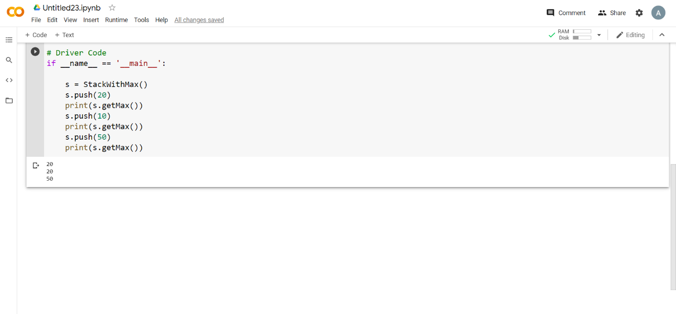

Q2) Write a function to find the minimum element in the stack.

